Dataset Resource Guide

Base Research Paper

Project Reference Paper:
Symmetric Boundary-Enhanced Mamba-UNet for Glomerulus Segmentation in Kidney Histopathology Images
The objective of the research is to accurately identify and segment glomeruli from kidney biopsy tissue images using deep learning-based segmentation models.

Dataset Used

HuBMAP - Hacking the Kidney Dataset
The HuBMAP dataset contains high-resolution digital pathology images of human kidney biopsy tissue. The dataset was created to support research in glomerulus segmentation and kidney disease analysis.
Instead of providing only images, the dataset provides multiple types of files that work together to describe the tissue and the location of glomeruli.

Understanding the Dataset
A simple way to understand the dataset is to imagine a large state map.
The TIFF image represents the entire state.
The JSON files represent GPS coordinates of important monuments.
The Anatomical JSON files describe larger geographical regions.
The CSV file acts as a directory that connects all available information.
When combined together, these files help researchers locate glomeruli and create datasets suitable for deep learning models.

1. TIFF Files (Whole Slide Images)
TIFF files are ultra-high-resolution digital scans of kidney biopsy tissue.
A kidney biopsy does not capture the entire kidney. Instead, a very small tissue sample is collected and placed on a microscope slide. This slide is then scanned using a pathology scanner to create a digital Whole Slide Image (WSI).
The resulting TIFF image contains a large tissue region with multiple biological structures, including glomeruli.
Each TIFF image may contain multiple glomeruli distributed across different tissue regions, making direct model training computationally expensive.

Analogy
Imagine having a complete map of a state.
The TIFF image is that entire map.
It contains everything present in the tissue, not just the structures we are interested in.
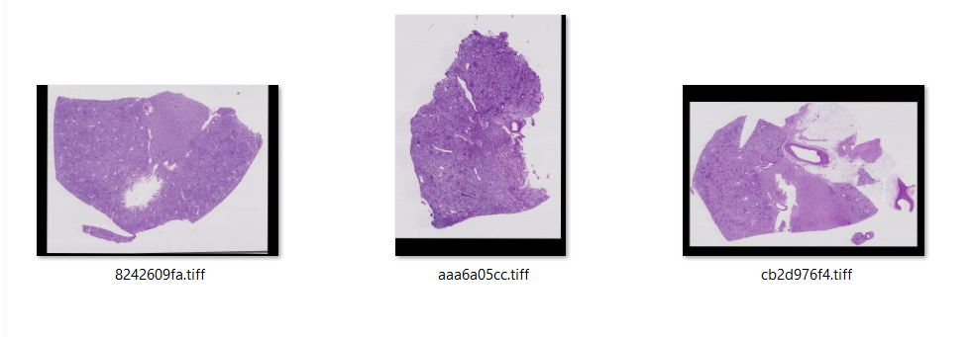
FIGURE: Tiff Files Picture [Note: Screenshot Image And Merged]

2. JSON Annotation Files
The JSON files contain the exact coordinates of glomeruli present inside the TIFF image.
These coordinates are manually annotated by medical experts and represent the ground truth used for segmentation.

Analogy
If the TIFF image is a state map, the JSON file acts like a GPS navigation system.
Instead of searching the entire state to find a monument, the GPS directly provides its exact location.
Similarly, the JSON file tells us exactly where each glomerulus is located within the TIFF image.

3. Anatomical Structure JSON Files
The Anatomical JSON files provide information about larger tissue regions and structures.
These files describe the surrounding anatomical context rather than individual glomeruli.

Analogy
Continuing the state map example:
The JSON file tells us where a monument is located.
The Anatomical JSON file tells us whether that monument is located in a city, forest, river region, plateau or another geographical area.
In the same way, anatomical annotations describe broader tissue regions surrounding the glomeruli.

4. CSV Metadata File
The CSV file contains metadata and information associated with the TIFF images and annotations.
It acts as a reference table connecting image identifiers, annotation information and other dataset details.

Analogy
If TIFF is the map and JSON files provide locations, then the CSV file acts like a directory book that keeps track of all available information.

Relationship Between Dataset Components
Each file contributes different information:
- TIFF → Contains the complete tissue image.
- JSON → Contains exact glomerulus locations.
- Anatomical JSON → Contains larger tissue region information.
- CSV → Contains metadata and references.
Individually these files provide partial information.
Together they provide a complete description of the tissue and the structures present within it.

From Raw Data to a Trainable Dataset
Deep learning models cannot efficiently process extremely large TIFF images directly.
Therefore, the information from TIFF images, annotation files and metadata is combined to create a smaller and more focused dataset.
The general workflow followed by glomerulus segmentation research is:
Whole Slide TIFF Image
↓
Read Annotation Coordinates
↓
Locate Glomeruli
↓
Generate Segmentation Masks
↓
Extract Relevant Image Regions
↓
Create Image–Mask Pairs
↓
Build Training Dataset
↓
Train Segmentation Models
↓
Perform Glomerulus Segmentation

Relevance to the Base Paper
The base research paper uses the HuBMAP dataset as the foundation for training and evaluating segmentation models.
The dataset provides the tissue images and annotation information required to create image-mask pairs, while the proposed Boundary-Enhanced Mamba-UNet architecture focuses on improving segmentation quality and boundary accuracy of glomeruli.
Thus, the dataset serves as the source of information, while the segmentation model serves as the learning system that interprets and analyzes that information.
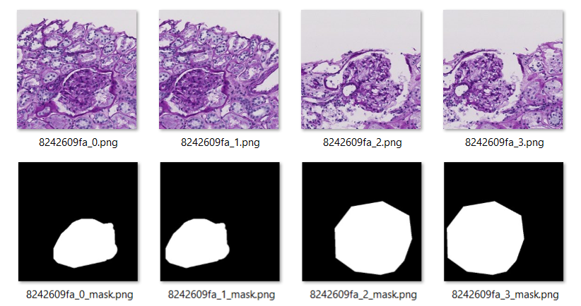
FIGURE: Example Image–Mask Pairs Generated from HuBMAP Whole Slide Images
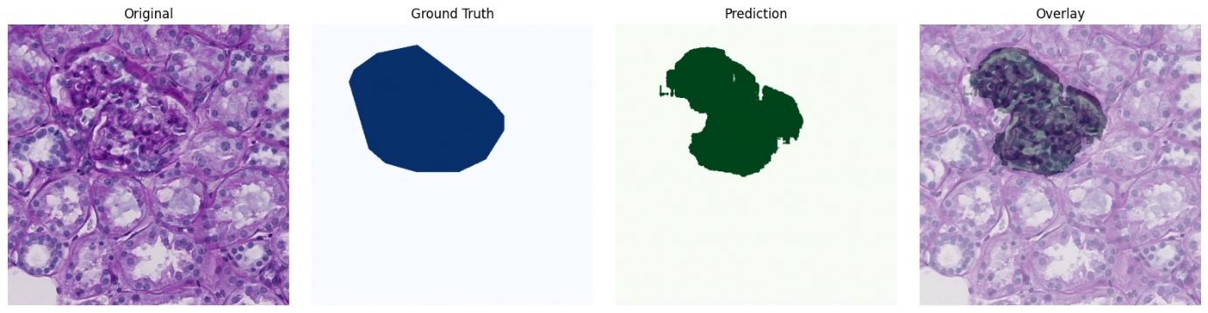
FIGURE: UNet Validation Example Showing Original Image, Ground Truth Mask, Predicted Mask, and Overlay Visualization

